**TaskTrackr Project Documentation**

Project Title: TaskTrackr: Student Productivity and Project Management Tool

1. Project Description

TaskTrackr is a web-based project and productivity management tool tailored for students to help them organize academic responsibilities, track tasks, and collaborate on group projects. It addresses common student challenges such as missed deadlines, poor group coordination, and overwhelming workloads by offering a centralized platform for time and task management. The system enables users to create tasks, assign deadlines and priorities, form and manage groups, collaborate on shared projects, and track overall progress through intuitive interfaces and smart notifications. With both individual and group productivity in mind, TaskTrackr supports an academic environment that encourages accountability, time management, and teamwork.

1. Objectives

Help students manage academic workloads efficiently. Minimize missed deadlines through reminders and task visibility. Facilitate collaboration and coordination in group projects. Provide a simple, user-friendly tool tailored to a student’s academic life. ---

1. Key Features
   * Task Management - Create, update, delete, and view tasks. Assign deadlines, priority levels (Low, Medium, High), and status (Pending, In Progress, Done). Each task is linked to a project and assigned to a user.
   * Project Dashboard - Create and manage academic projects. View project details including description, deadline, and assigned group. Each project is associated with a category (e.g., Thesis, Personal).
   * Calendar View - Visual display of task and project due dates. Helps students plan their week/month effectively.
   * Group Collaboration - Create or join groups with fellow students. Groups can be assigned to one or more projects. Enables shared visibility of group tasks.
   * Progress Tracking - Real-time statistics on task completion. View individual and group task status updates.
   * Smart Notifications - Automated reminders for upcoming and overdue tasks. Email or in-app alerts based on deadlines and priorities.
   * Project Categorization - Projects can be categorized for easy sorting and filtering. Custom categories like “Capstone”, “Personal”, “Homework”, etc.
2. System Users

Students: Default user role with access to personal and group tasks. Group Members: Collaborate on projects and view group task progress. (Optional): Admin roles for system management. ---

1. Technology Stack
2. Entity Relationship Diagram (ERD) – Summary

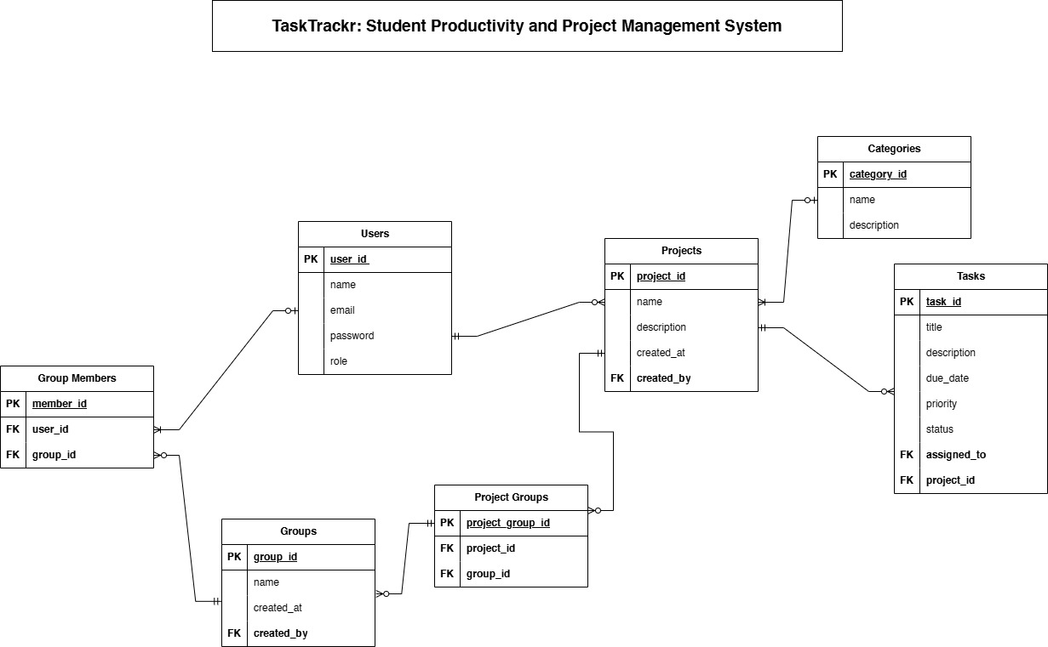

1. Business Rules

A user may have zero or many tasks; each task must belong to one user. A project may or may not be assigned to groups. A group may or may not be linked to projects. A task must belong to one project. A project must be categorized under one category. A category can have many projects. Users can belong to many groups; each group must have at least one user.

1. Deliverables

Fully functional TaskTrackr web application Source code (frontend + backend) Database file (.sql or Firestore export) Printed documentation (this file) Screenshots of each feature Sample SQL queries Final recorded demo presentation

1. Reflection

Through the development of TaskTrackr, we applied database design principles, relational modeling, and CRUD functionality in a real-world scenario. We gained hands-on experience in SQL, web development, and teamwork, reinforcing our understanding of system analysis, user-centered design, and backend integration. This project allowed us to solve a problem we ourselves face as students—task overload and poor collaboration—and turn that into a digital solution that’s both practical and scalable.